Nov 4, 2019
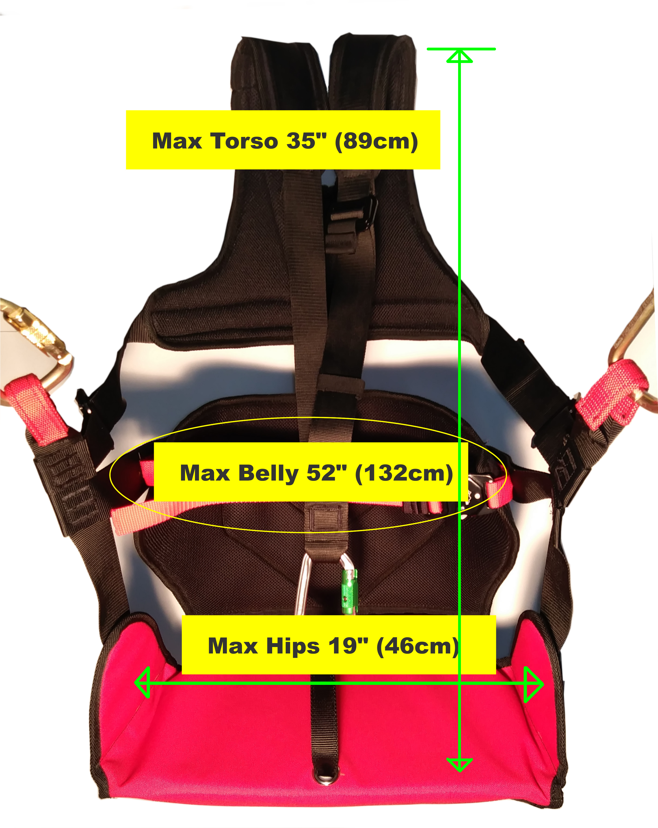

Dimensions:
- Max torso is about 35” (fits most riders up to 6’6” tall)
- Max belly is about 52” (fits most riders under 250 lbs )
- Max hips is about 19” (fits most riders under 250 lbs)

Larger riders may use our Balboa or WallTee L-XXL harness.

